Name: | ___________________________________________________ |  |  | Date: ___________
 | Year 8 Mathematics  Test 4, 2015  Topics – Linear Relationships |  |  | 55  = %
Total Time: | 60 minutes
Total Reading: | 5 minutes
Total Working: | 55 minutes
SECTION 1: CALCULATOR FREE
Time: | 36 minutes | Marks for Section 1: | 33
Reading: | 3 minutes | Equipment Allowed: | ½ page notes (A4 one side)
Working: | 33 minutes

1. | [6 marks: 3, 1, 2]
 | Complete the sentences from the list of words below:
Cartesian linear graph gradient
x-axis variable y intercept y- axis
a) | The plane has two axes. The Horizontal axis is called the and the vertical axis is called the .
b) | A rule that produces a straight line is called a function .
c) | The of a line is also called the slope and the is where the line touches the y axis.

2. | [4 marks: 2, 2]
 | Complete the tables below:
a)
  x | 1 | 2 | 3 | 4 | 5 | 6
  y | 5 | 8 | 11
b)
  x | 1 | 2 | 3 | 4 | 5 | 6
  y | 13 | 8 | 3

3. | [5 marks: 1, 1, 1, 1, 1]
 | Write down the coordinates for A, B, C, D and E.
 | 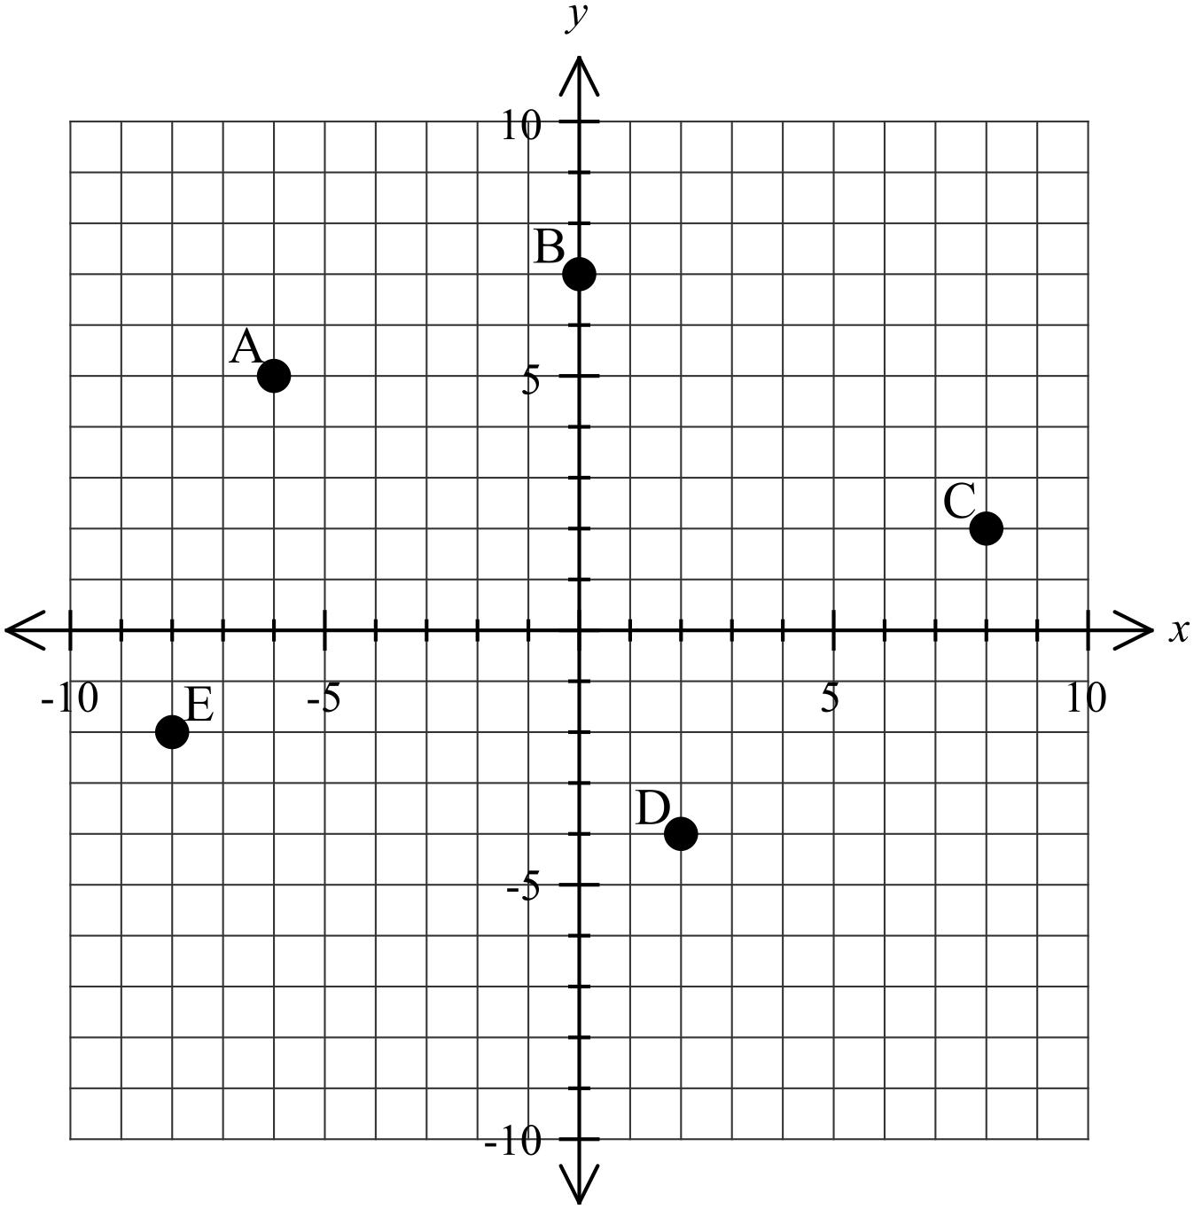
 | A ( , ) B ( , ) C ( , ) D ( , ) E ( , )

4. | [4 marks: 1, 1, 1, 1]
 | Plot the following coordinates on the graph below.
 | F = (–2 , 4) , G = (5 , 0) , H = (9 , –8) , I = ( 0 , 3)
 | 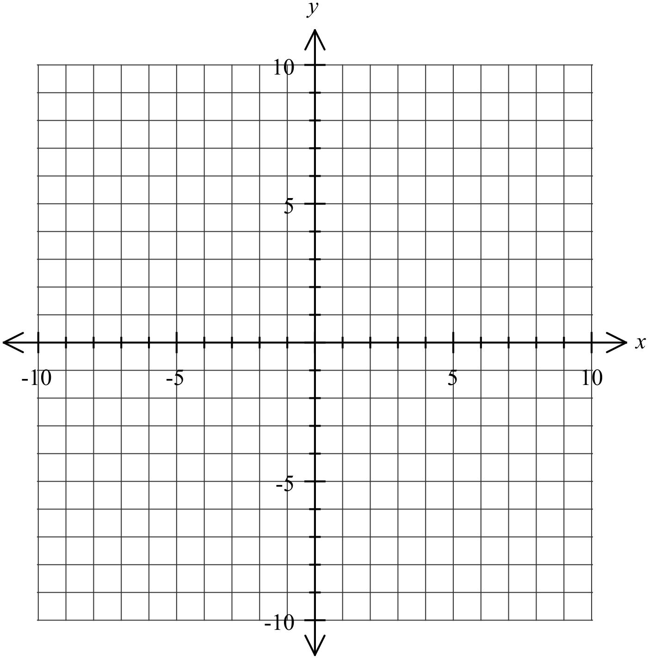

5. | [4 marks: 2, 2]
 | Complete the following tables:
a) | y = 4x + 2
x | 0 | 1 | 2 | 3 | 4 | 10
y

b) | y = –2x – 5
x | 0 | 1 | 2 | 3 | 4 | 10
y

6. | [4 marks: 2, 2]
x | 1 | 2 | 3 | 4 | 5 | 6
y | 3 | 5 | 7 | 9 | 11 | 13

a) | From the table above write a rule in the form of y =……….
b) | Graph the table above.
 | 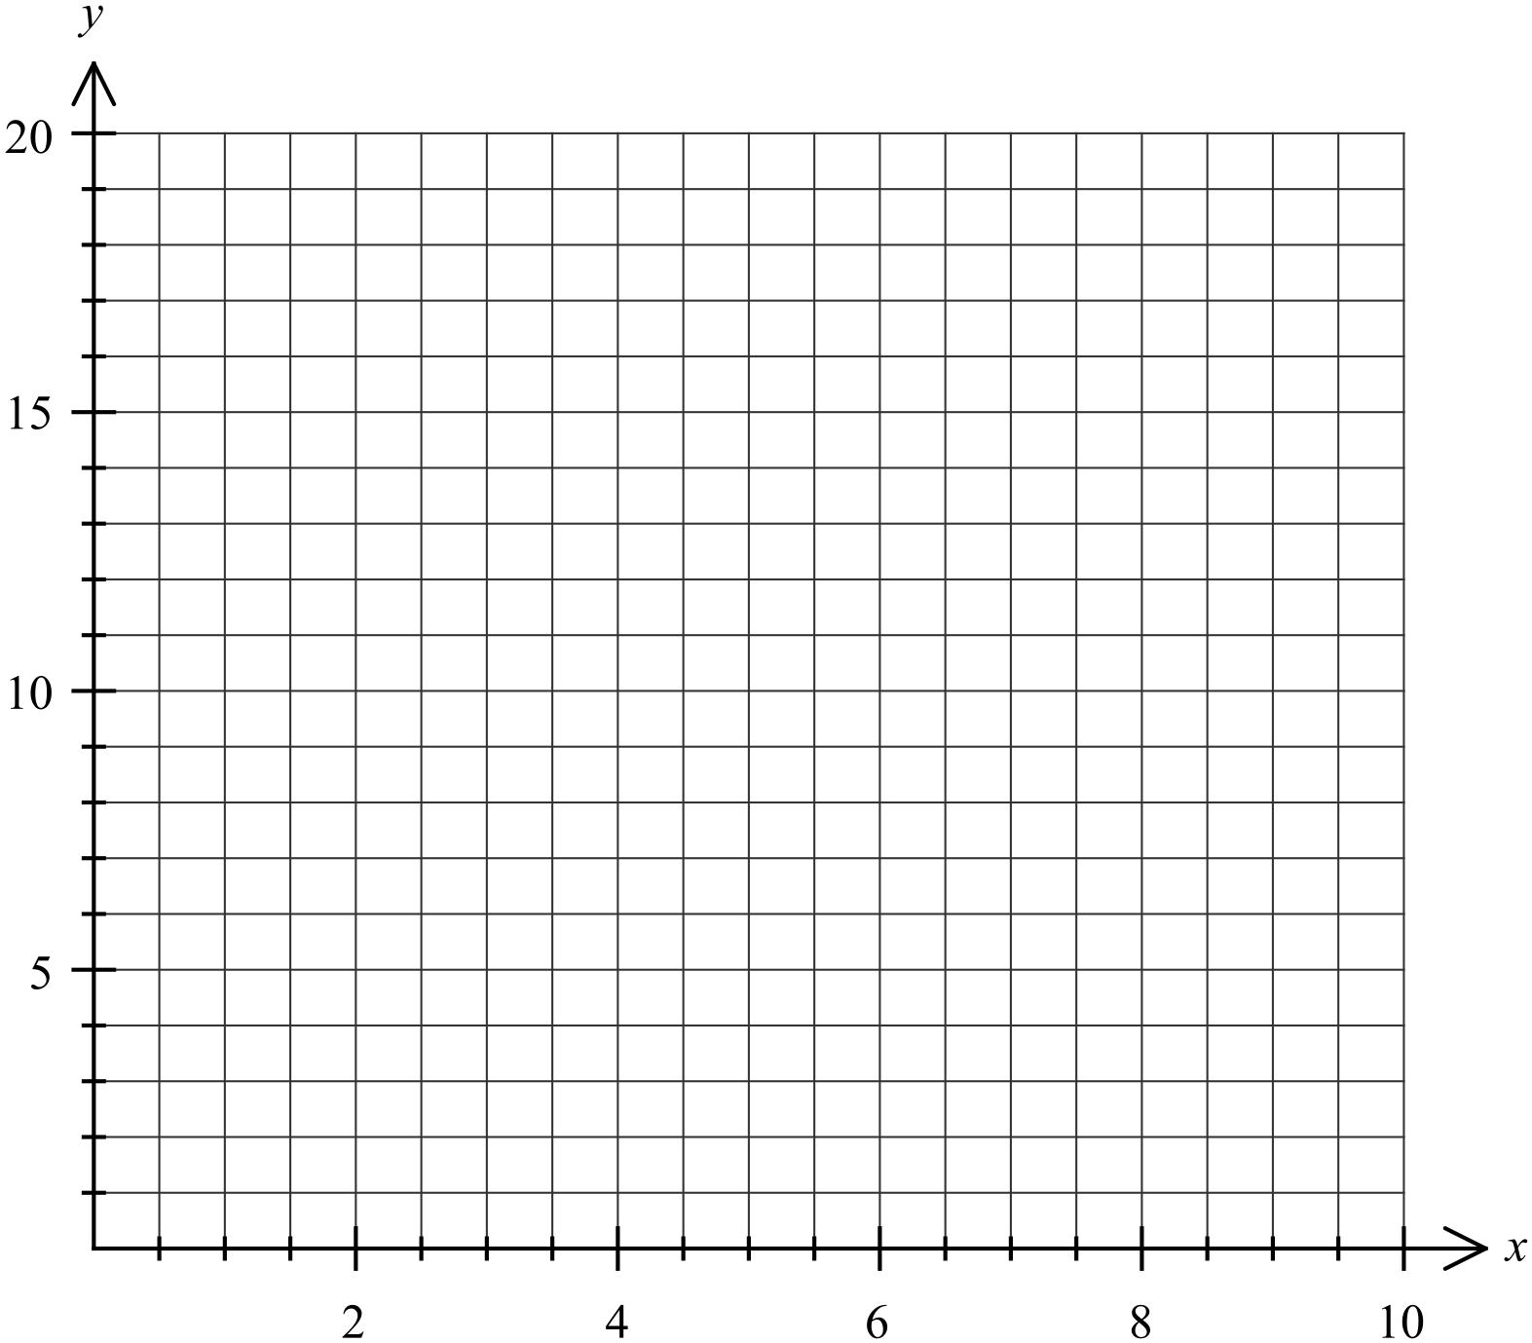

7. | [6 marks: 2, 2, 2]
 | For each of the following tables, determine if they show a linear relationship. Explain why.
a)
  x | 1 | 2 | 3 | 4 | 5 | 6
  y | 10 | 14 | 18 | 22 | 26 | 30
 | Linear relationship: YES / NO
 | Explanation:
b)
  x | 1 | 2 | 3 | 4 | 5 | 6
  y | 1 | 3 | 9 | 27 | 81 | 243
 | Linear relationship: YES / NO
 | Explanation:
c)
  x | 1 | 2 | 3 | 4 | 5 | 6
  y | 100 | 89 | 78 | 67 | 56 | 45
 | Linear relationship: YES / NO
 | Explanation:

~ END OF TEST SECTION 1 ~

Name: | ___________________________________________________ |  |  | Date: ___________
SECTION 2: CALCULATOR ASSUMED
Time: | 24 minutes | Marks for Section 2: | 22
Reading: | 2 minutes | Equipment Allowed: | ½ page notes (A4 one side), Scientific calculator
Working: | 22 minutes

8. | [5 marks: 1, 1, 1, 2]
 | Calculate the gradient and the y-intercept for the following:
 | Equation | Gradient | y – intercept
a) | y = 5x – 2
b) | y = –6x
c) | y = 10 – 2x
d) | 2y + x = 4

9. | [5 marks: 2, 2, 1]
 | A plumber charges $25 an hour plus a set call out charge of $15.
a) | Create a rule to show the plumbers total cost (c), with hours (h).
b) | Plot your rule on the graph paper below.
 | 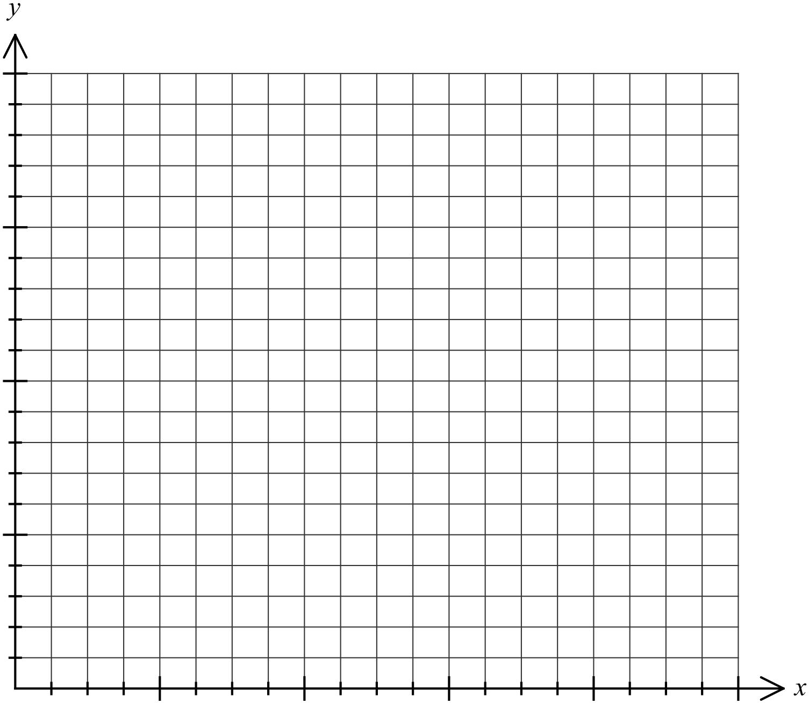
c) | How much would it cost to have the plumber for 12 hours?

10. | [8 marks: 2, 2, 2, 2]
 | Draw the following equations on the graph below:
 | a) | y = –x + 2 | b) | y = 3x – 4 | c) | y = 5 – 2x | d) | 2x – 3y = 12

11. | [4 marks: 2, 2]
 | Find the rule for Line 1 and Line 2 from the graph below.
 | 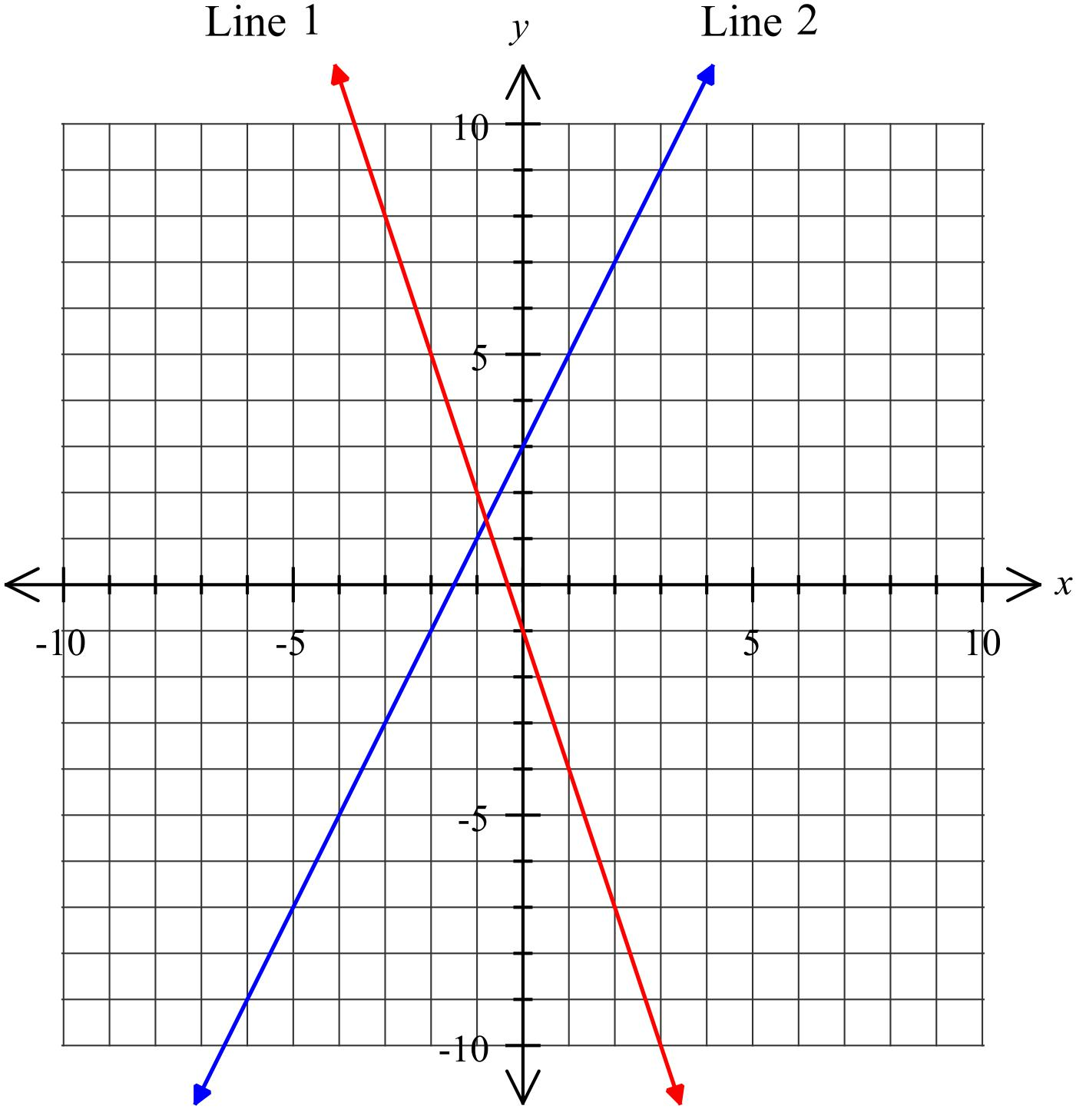
 | Line 1 Line 2

~ END OF TEST SECTION 2 ~

